Year  8 |  | Volume | Non Calculator  Section
Skills and Knowledge Assessed:  - Draw different views of prisms and solids formed from combinations of prisms (ACMMG161)  - Choose appropriate units of measurement for area and volume and convert from one unit to another (ACMMG195)  - Develop the formulas for volumes of rectangular and triangular prisms and prisms in general. Use formulas to solve problems involving volume (ACMMG198)  - Calculate the surface area and volume of cylinders and solve related problems (ACMMG217) Extension |  |  | Name___________________
Answer all questions in the spaces provided on this test paper by:
Writing the answer in the box provided.
or
Shading in the bubble for the correct answer from the four choices provided.
Show any working out on the test paper. Calculators are not allowed.
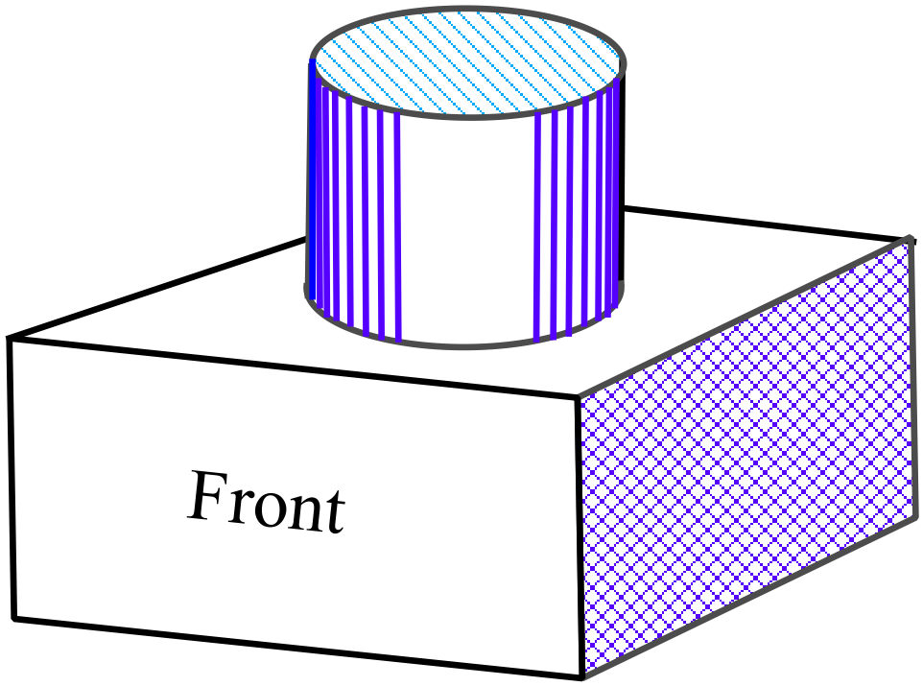For the solid shown, which diagram below correctly shows its front view (elevation) and top view (plan).

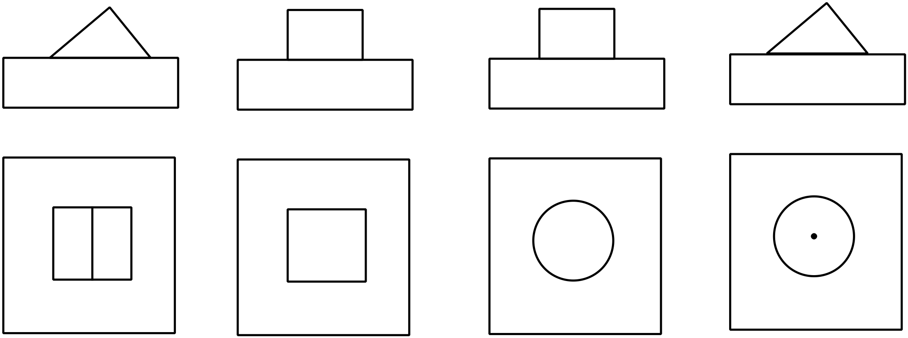

Draw a three dimensional sketch of the prism whose net is shown below.
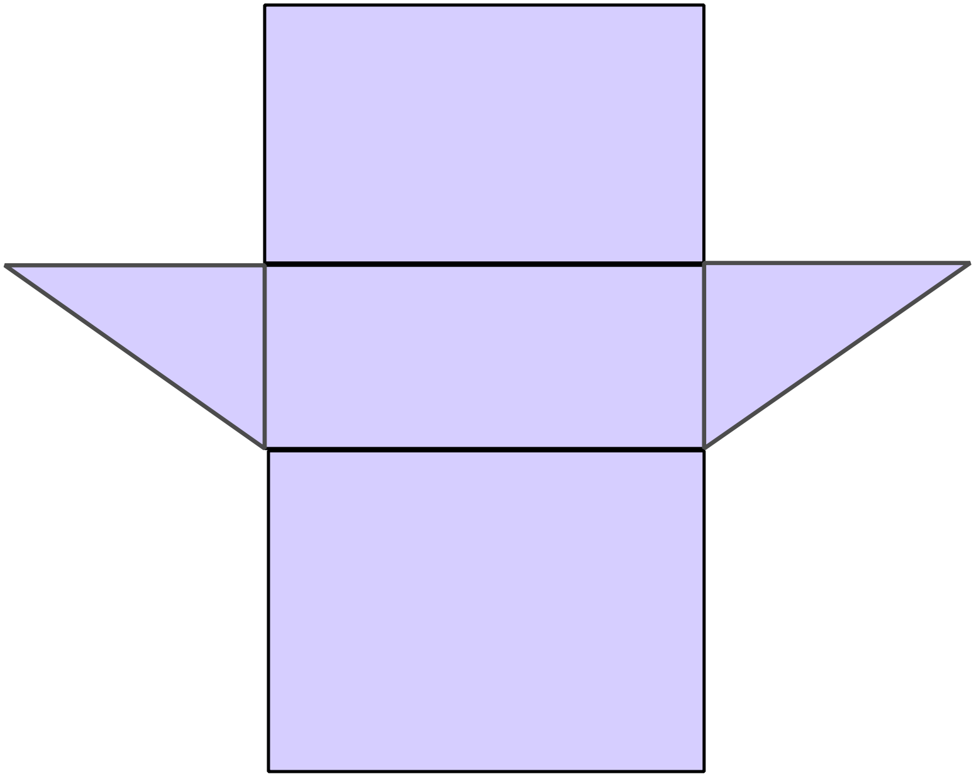

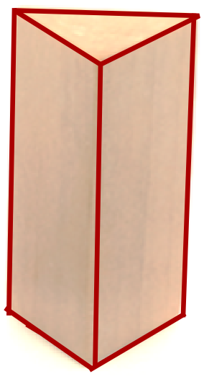What name describes the solid shown?

Rectangular Prism.

Rectangular Pyramid.

Triangular Prism.

Triangular Pyramid.

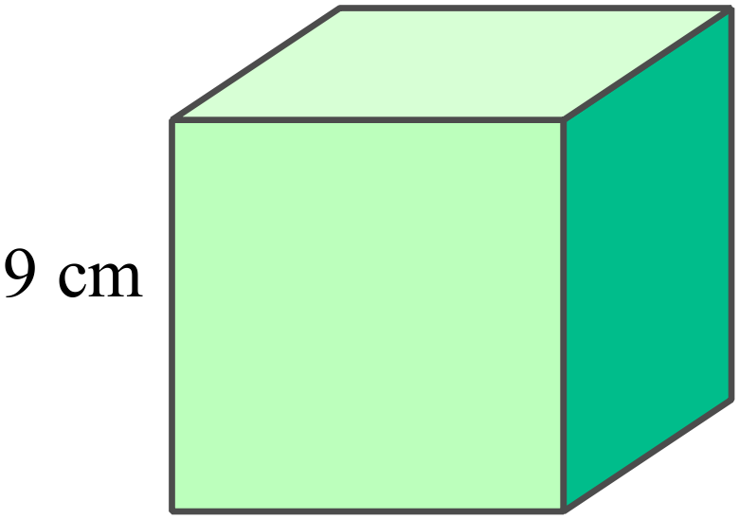What is the volume of the cube shown?

Volume = cm³

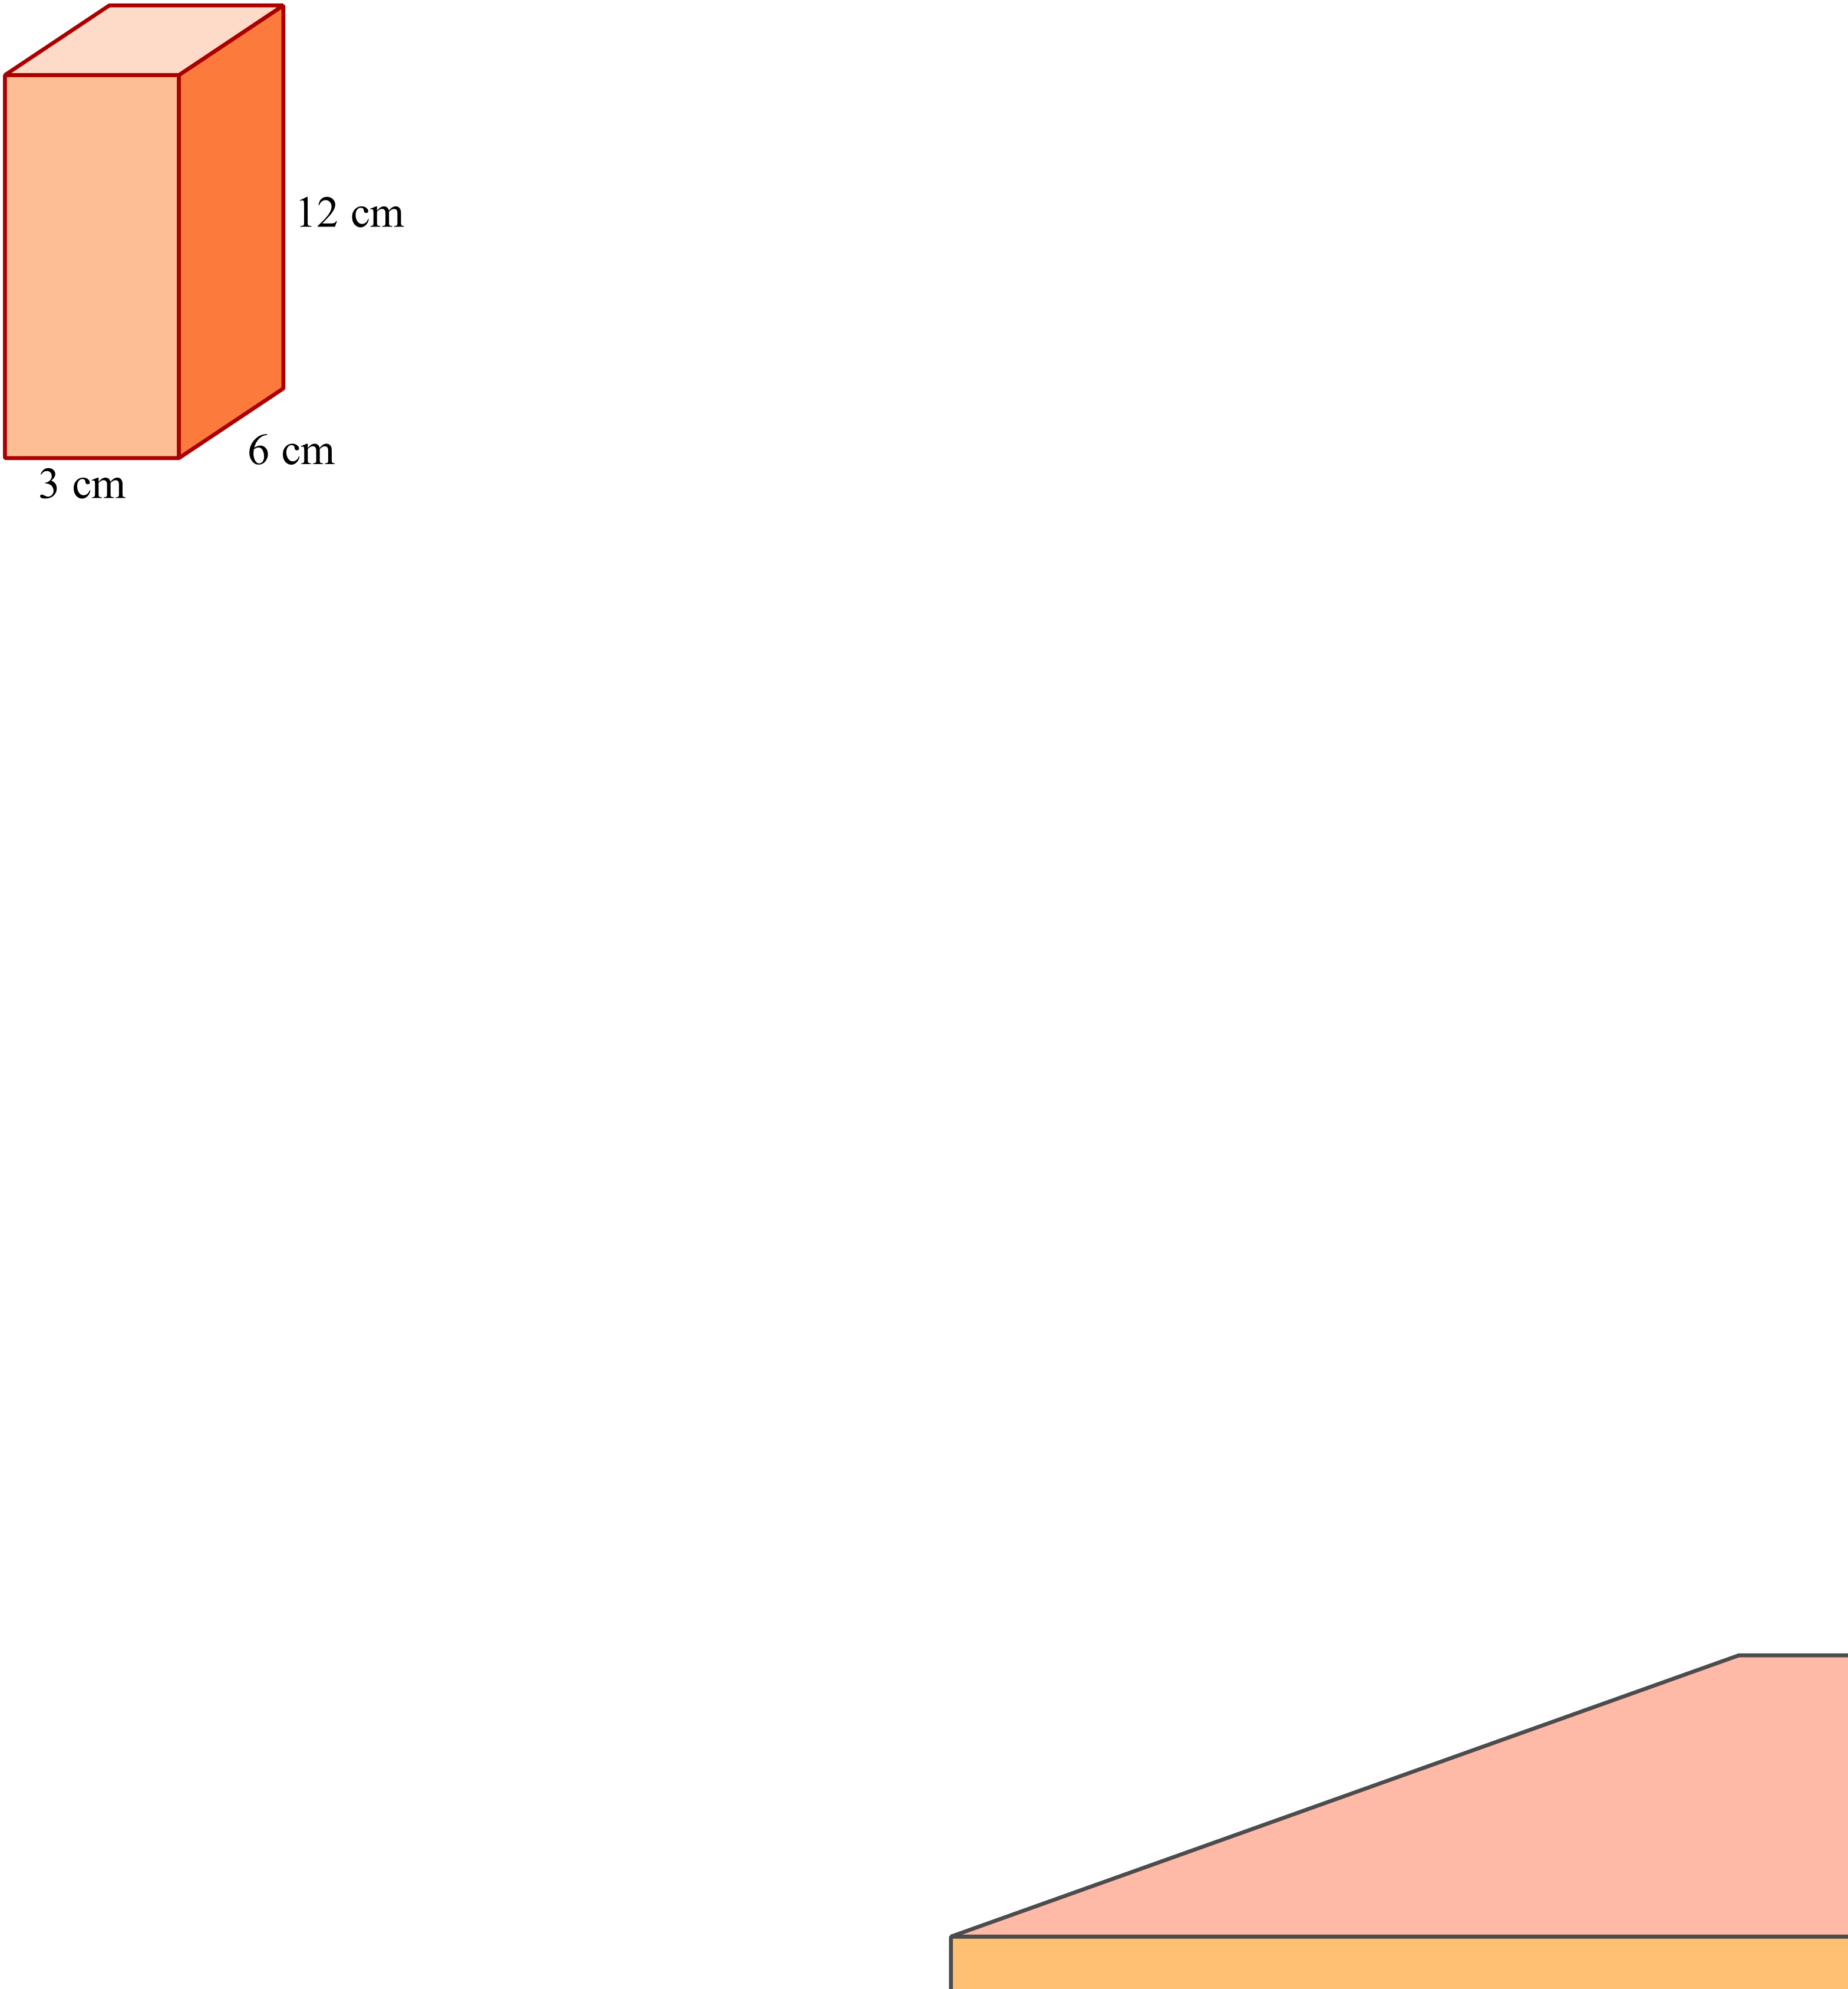What is the volume of the rectangular prism?

Volume = cm³

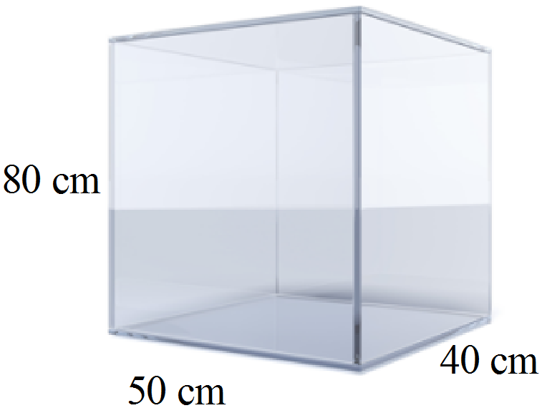Jimmy buys the glass aquarium shown and fills it to within 10 cm of the top.

How many litres of water are needed?

(1000 cm³ holds one litre.)

70 litres.

80 litres.

140 litres.

160 litres.

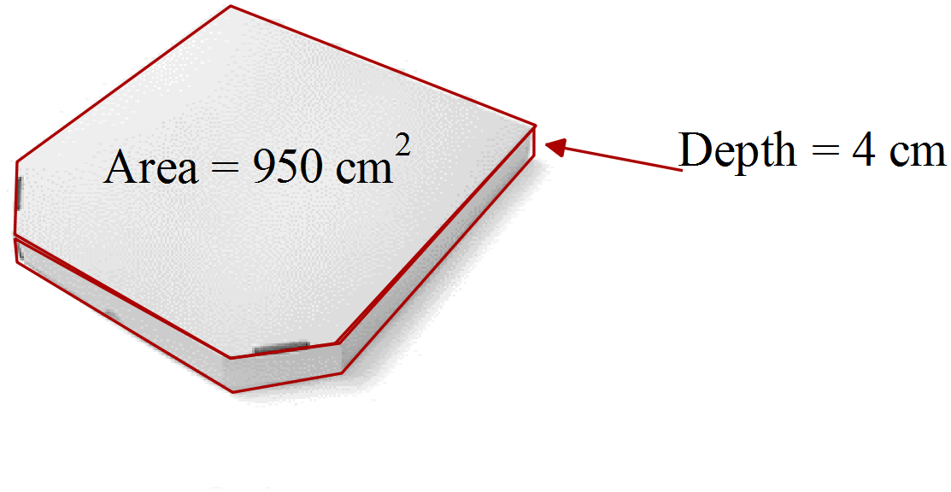Josie buys a pizza in the box shown.

What is the volume of the box?

Volume = cm³

What is the volume of the prism whose net is shown here?
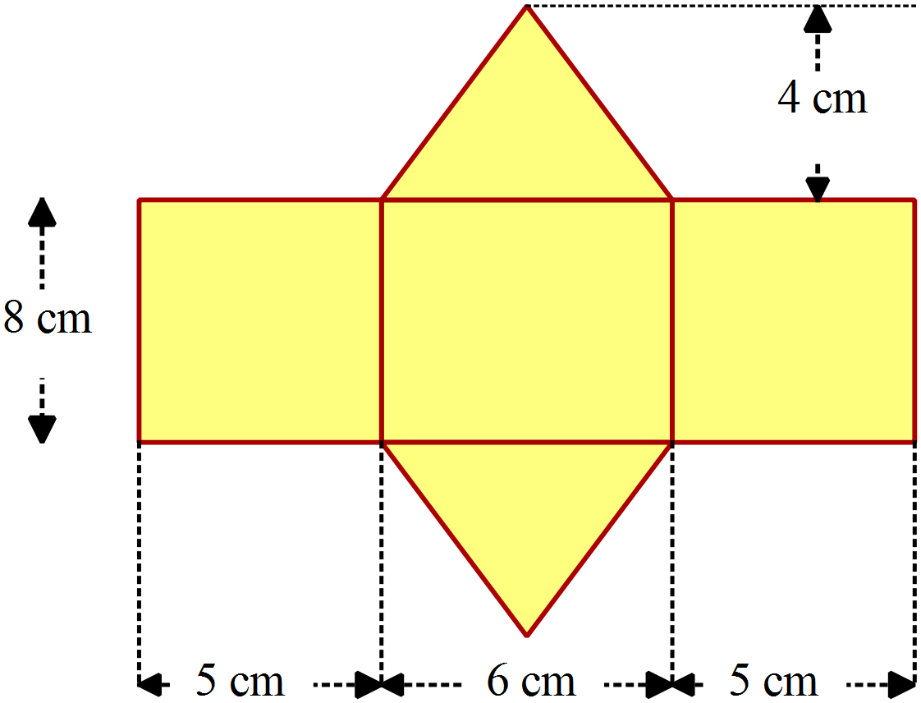

Volume = cm³

What is the volume of the triangular prism shown?
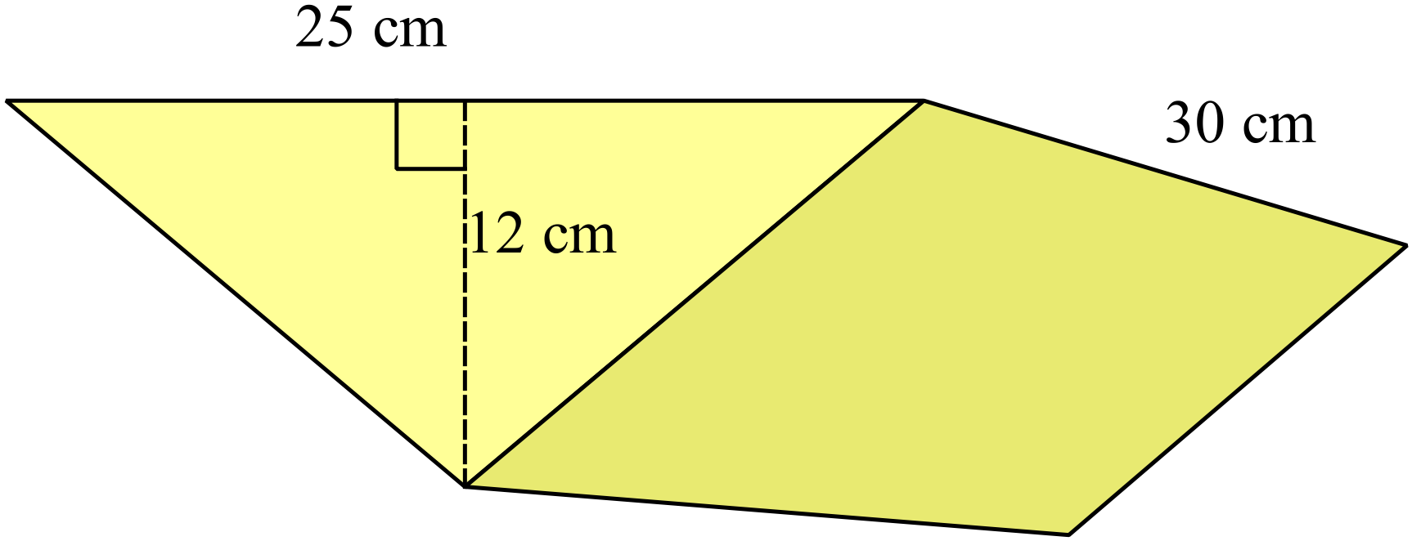

900 cm³

4 500 cm³

9 000 cm³

18 000 cm³

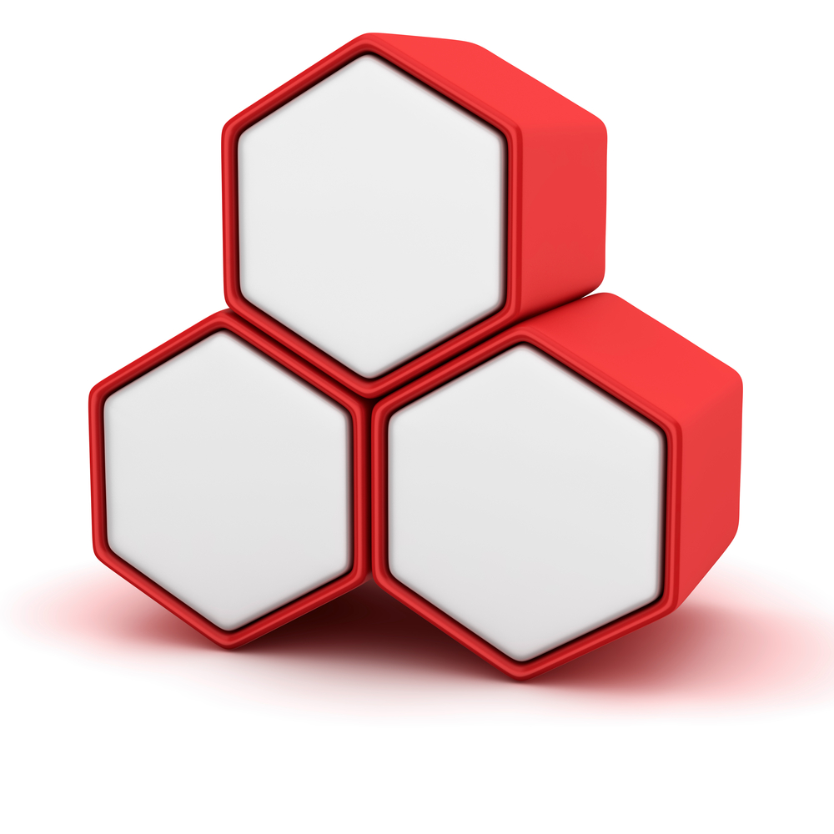
Each of these hexagonal boxes has a depth of 12 cm and the hexagonal top of each has an area of 90 cm².

What is the total volume of all the boxes shown?

Volume = cm³

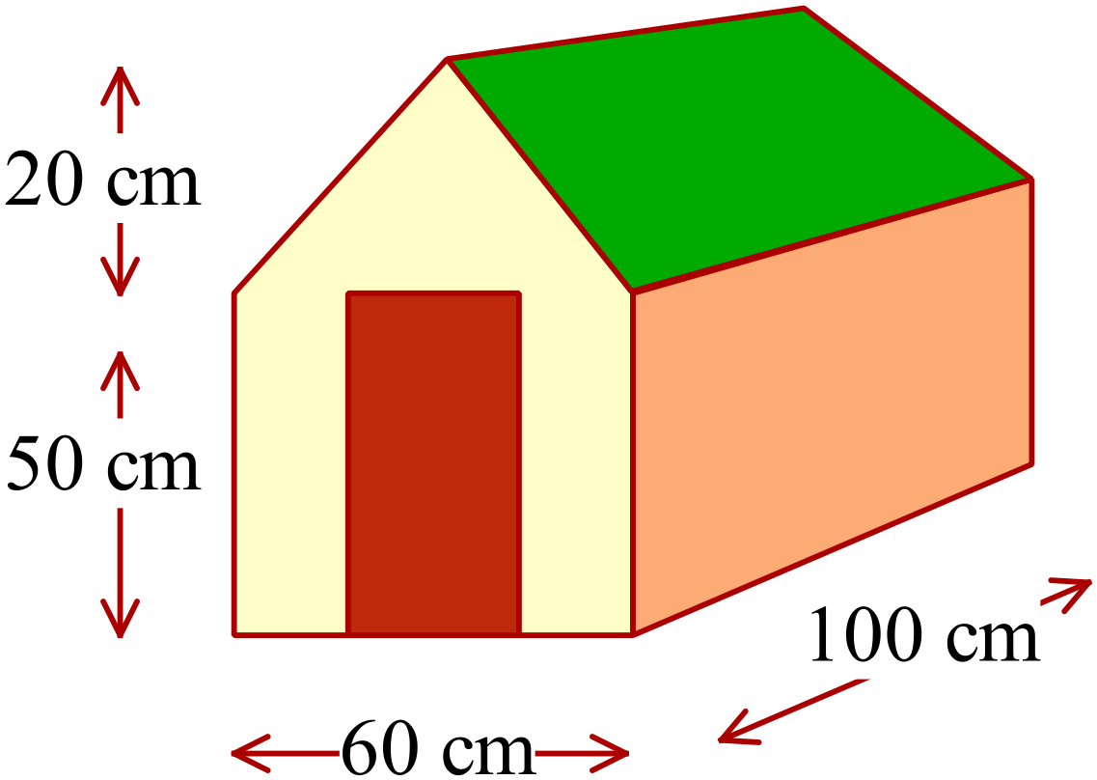A dog kennel has the dimensions shown.
Calculate the volume of the kennel in cm³.

Volume = cm³.

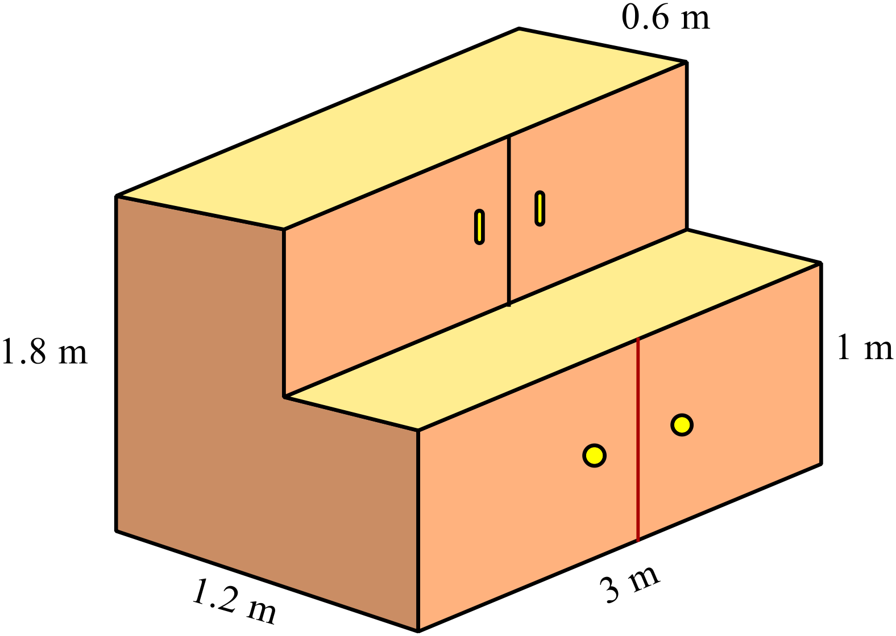A storage cabinet is in the shape shown.
What volume of storage does the cabinet provide?

Volume of Storage = m³.

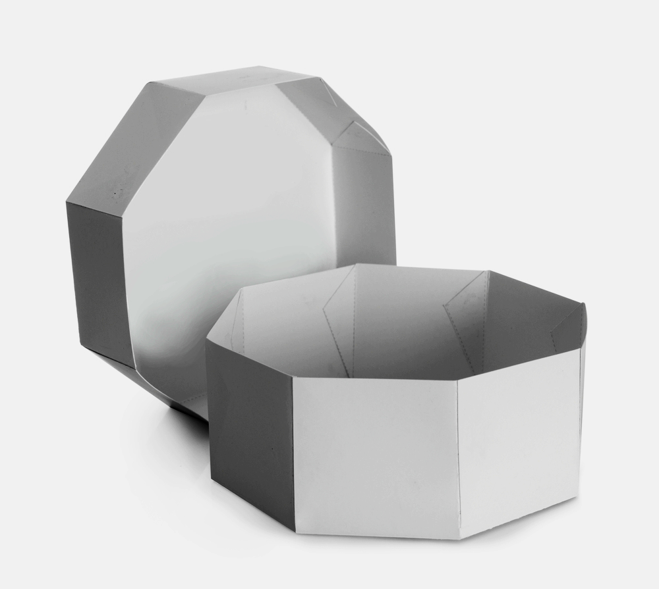
A gift box is in the shape of an octagonal prism that has 20 cm edges, measures 48 cm across and is 20 cm deep.
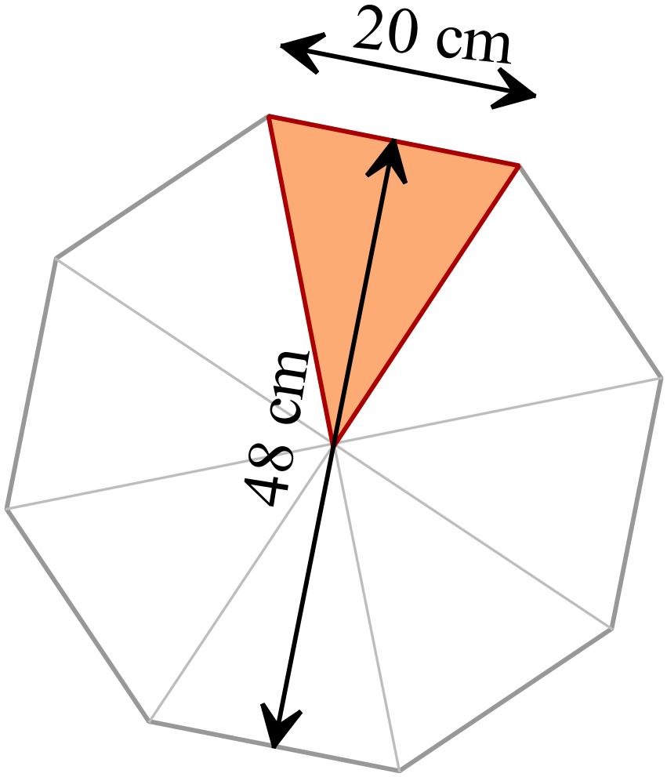
The octagon can be thought of as 8 isosceles triangles as shown.

Find the volume of the box.

Volume = cm³

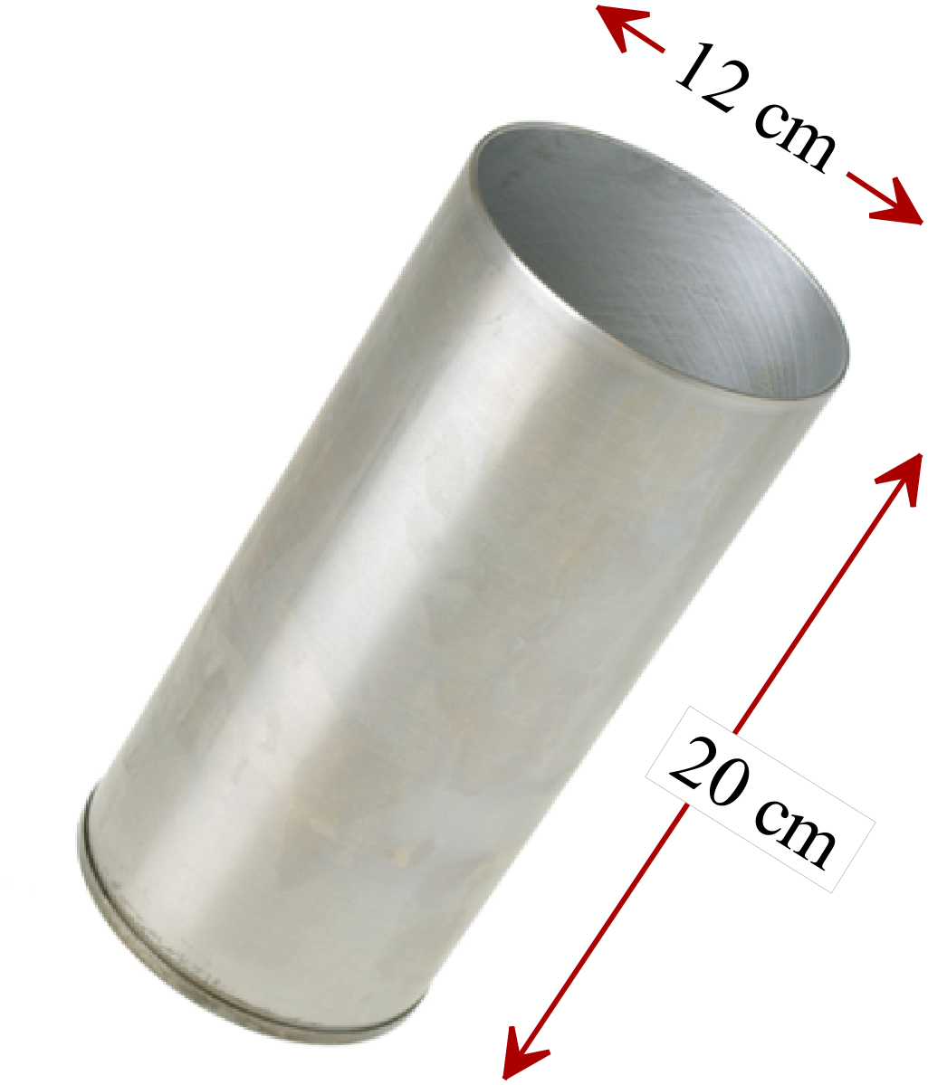Find the volume of the cylinder in terms of 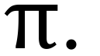

Volume = cm³

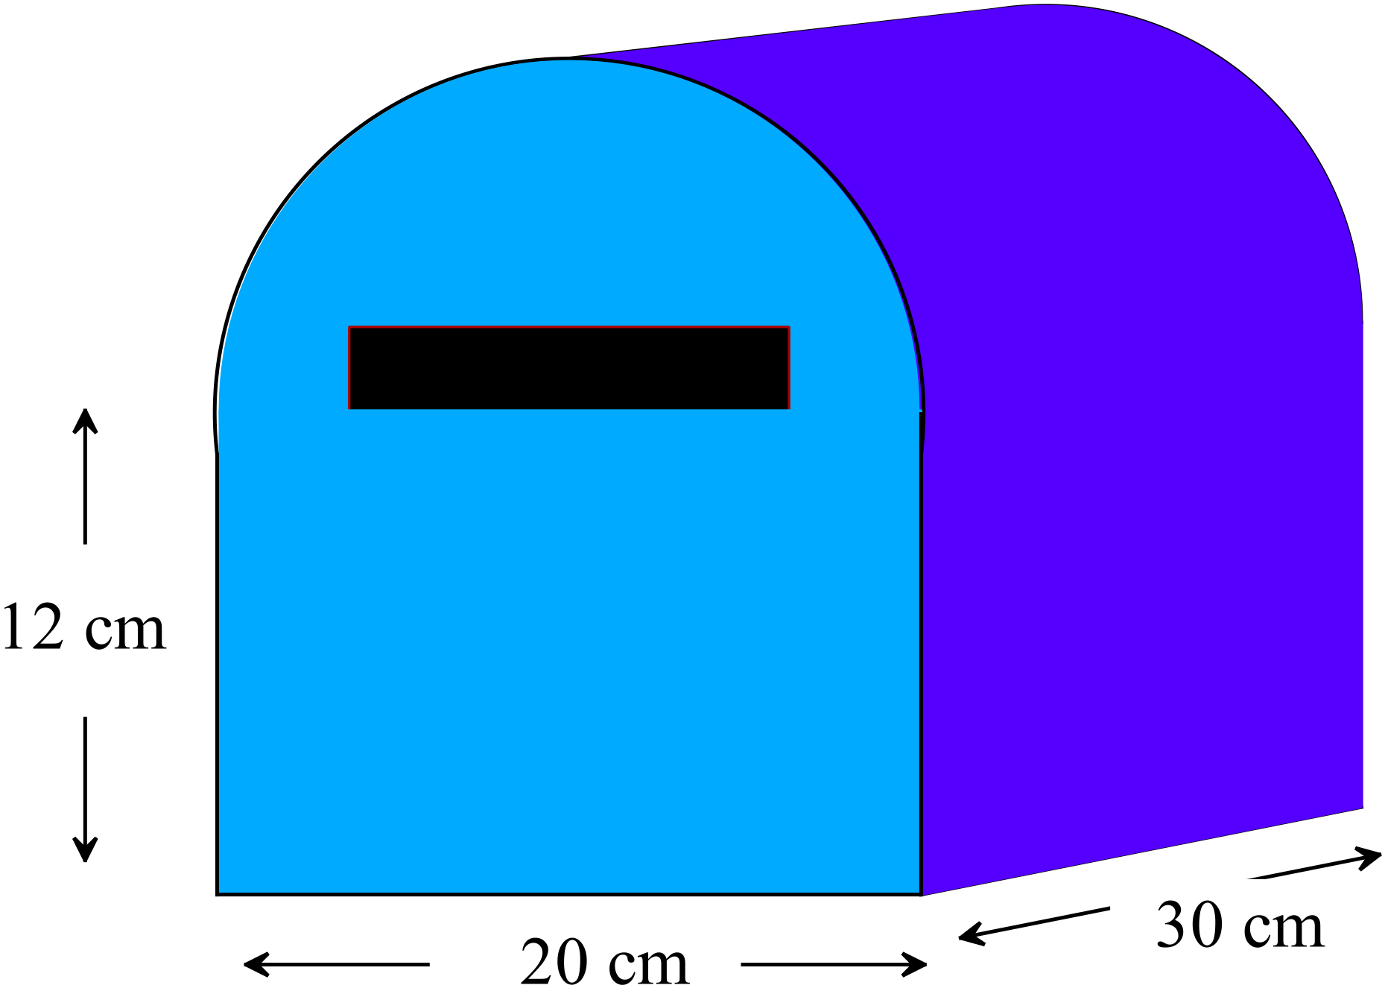A letter box is a prism with its cross section shown below.

What is the volume of the lunch box?

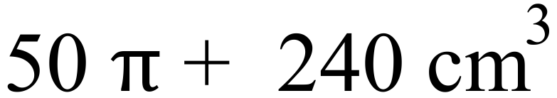
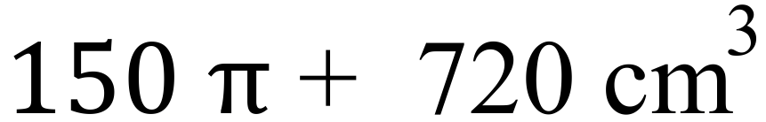
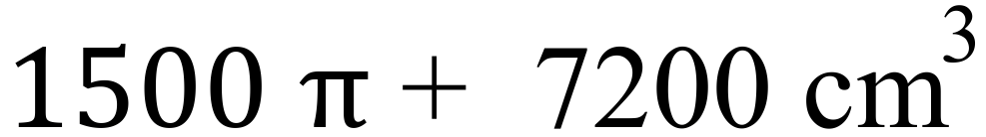
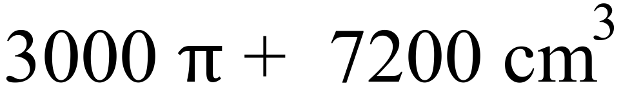

Year  8 |  | Volume | Calculator Allowed  Short Answer  Section
 |  |  | Name___________________
Answer all questions in the spaces provided on this test paper by:
Writing the answer in the box provided.
or
Shading in the bubble for the correct answer from the four choices provided.
Show any working out on the test paper. Calculators are allowed.
Which solid below is not a prism?
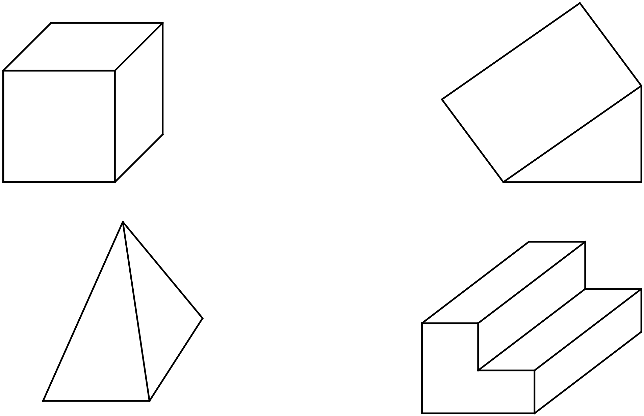

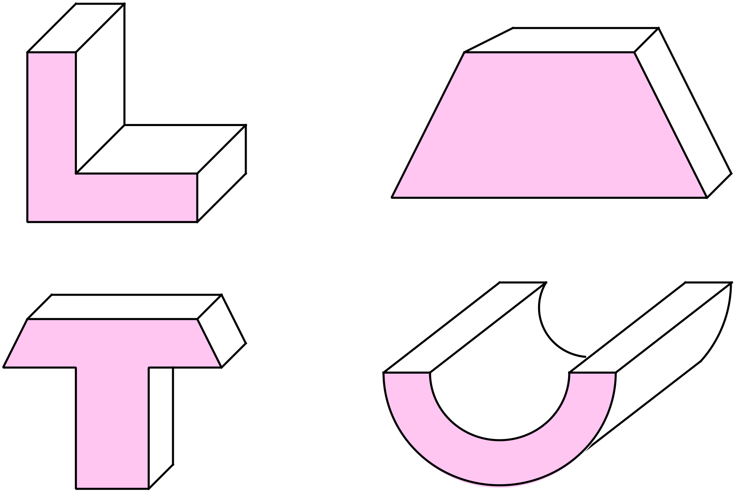Which of the solids shown would have the top and side view below?
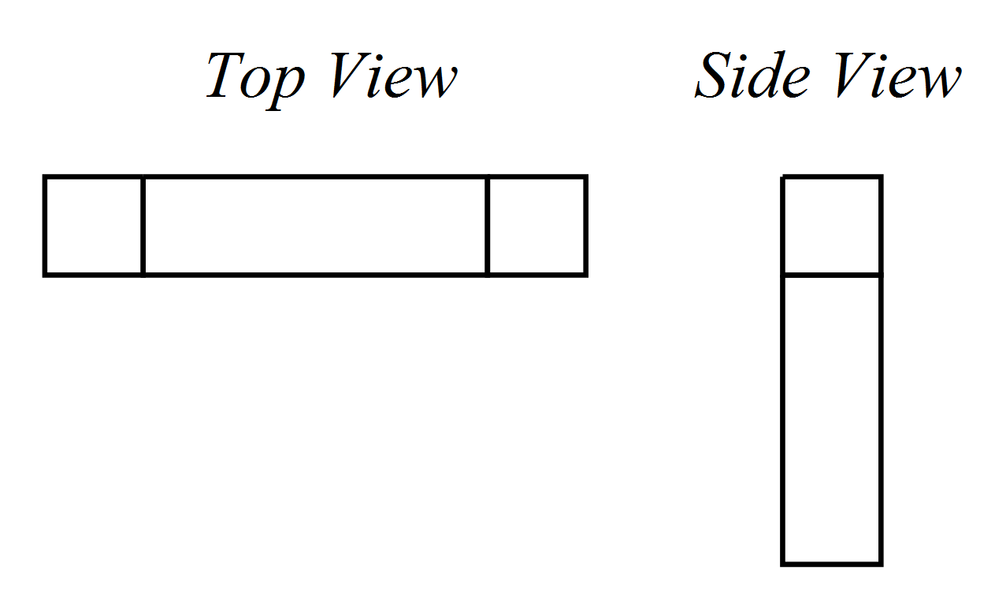

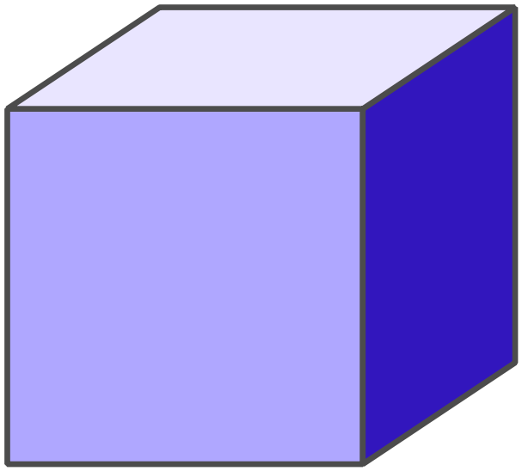The cube shown has a volume of 42.875 cm³.

What is the length of its edge?

Length = cm.

What is the volume of the rectangular prism?
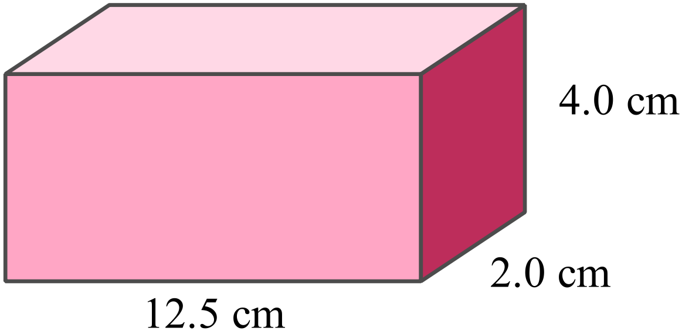
25.0 cm

50.0 cm

100.0 cm

125.0 cm

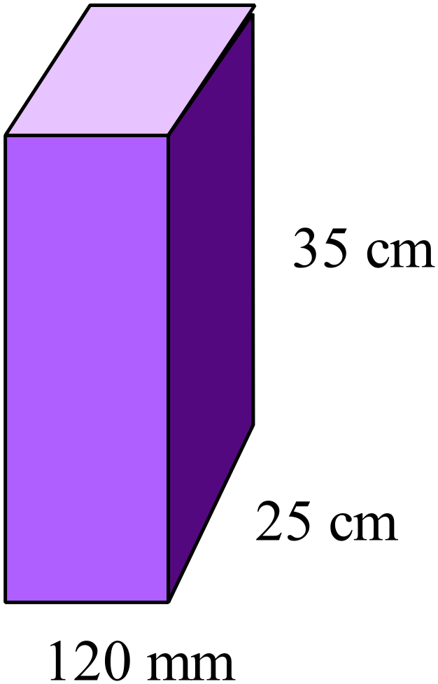What is the volume of the prism shown in cm³?

105 cm³
1 050 cm³
10 500 cm³
105 000 cm³

A prism has a volume of 6.5 m³. What is its volume in cm³?

650 cm³ 65 000 cm³ 650 000 cm³ 6 500 000 cm³

Each of the cubes used in this design measure 2 cm on each side.
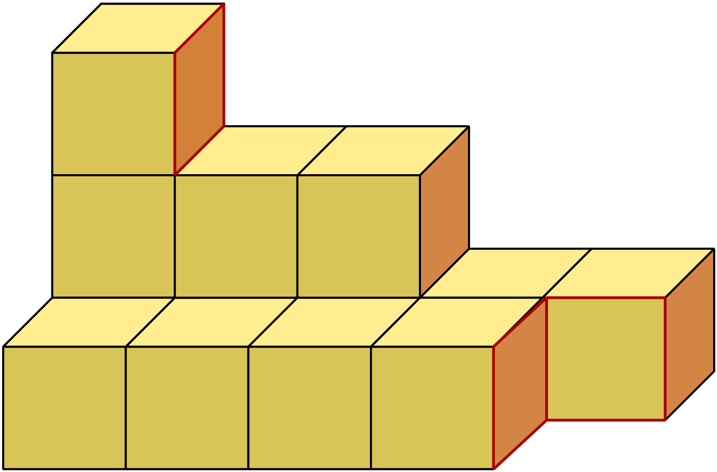
What is the total volume of the design?

13 cm³

26 cm³

52 cm³

104 cm³

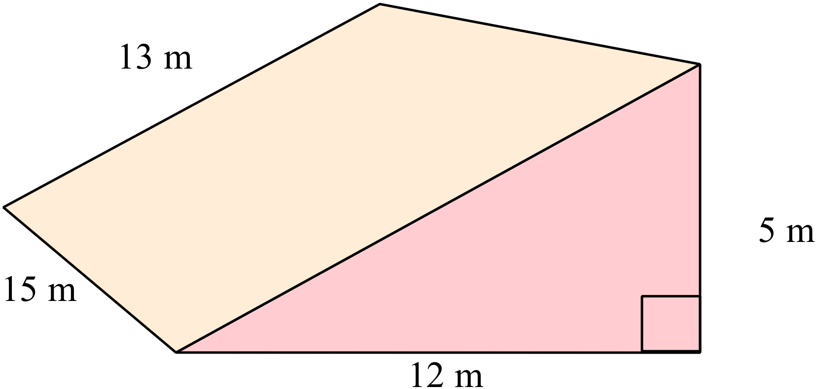Which calculation could be used to find the volume of the triangular prism shown?

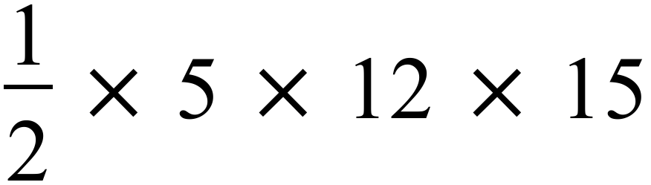

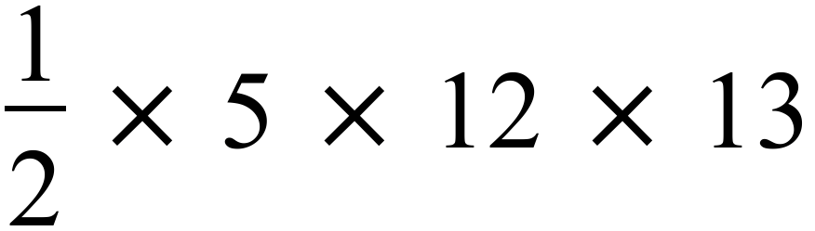

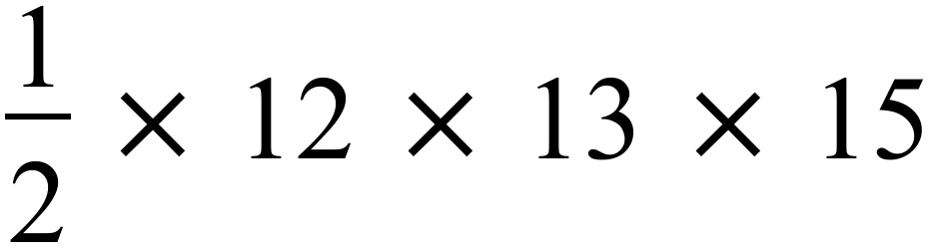

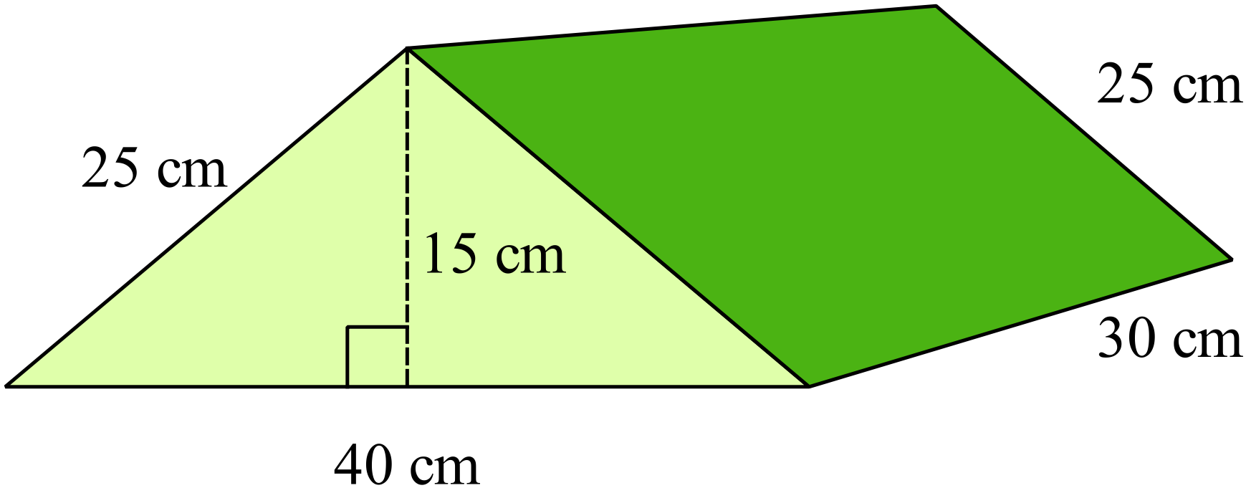Find the volume of the triangular prism shown.

Volume = cm³

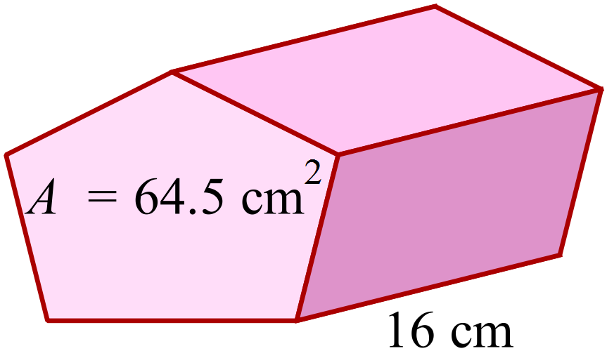The area of the pentagonal base of this prism is 64.5 cm².

What is the volume of the prism?

Volume = cm³

The water tank is designed to go under a deck and has the dimensions shown below.
Using the relationship: 1 cubic metre holds 1 kilolitre; find the capacity of the tank in litres.

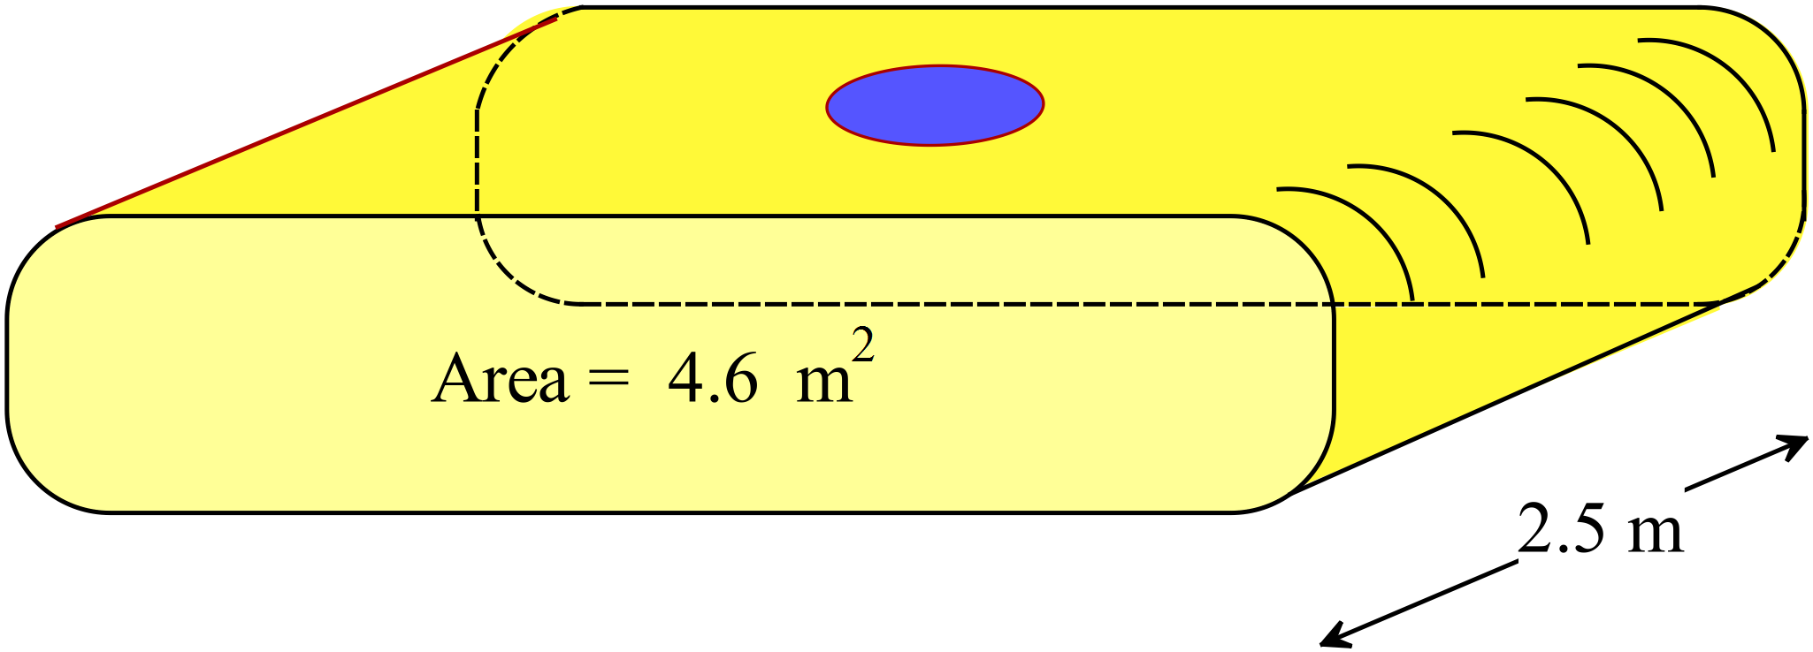

Capacity = litres.

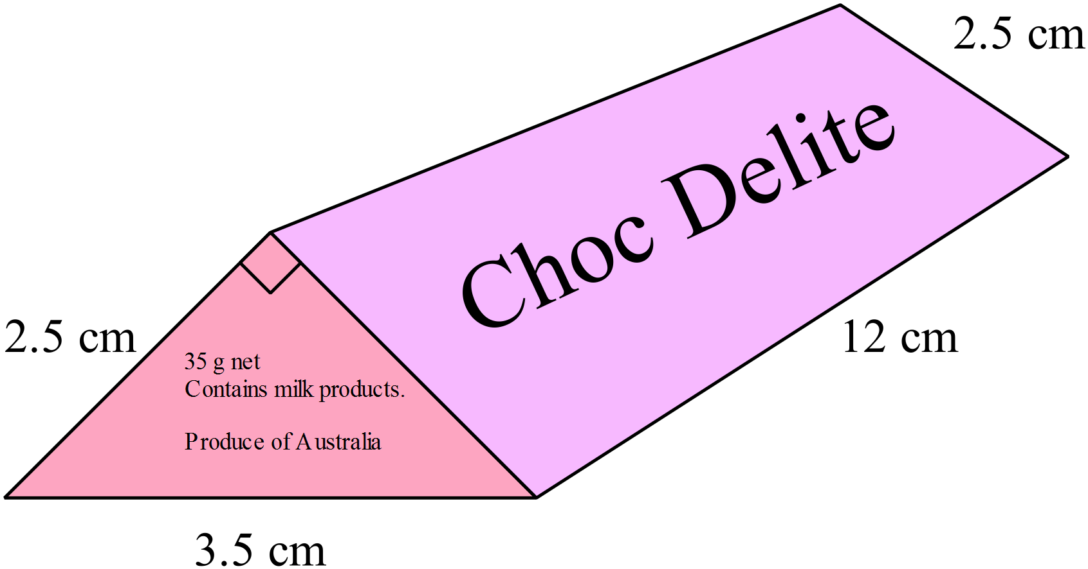Choc Delites are sold in a packet which is a triangular prism.

What is the volume of the packet shown?

35 cm³
37.5 cm³
52.5 cm³
131.25 cm³

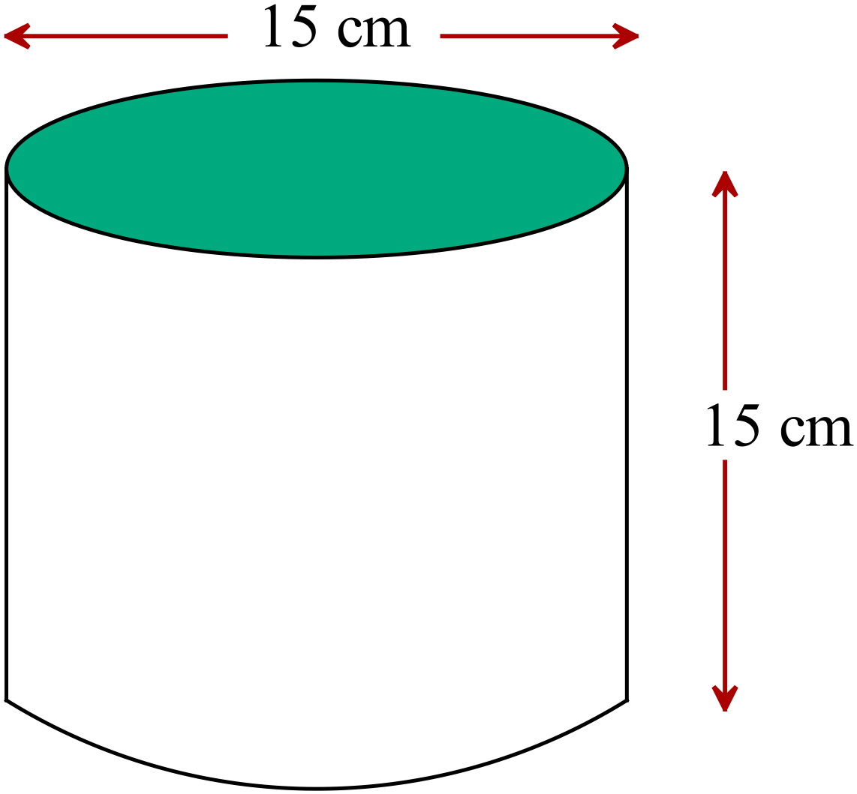What is the volume of the cylinder to the nearest cm³?

Volume = cm³.

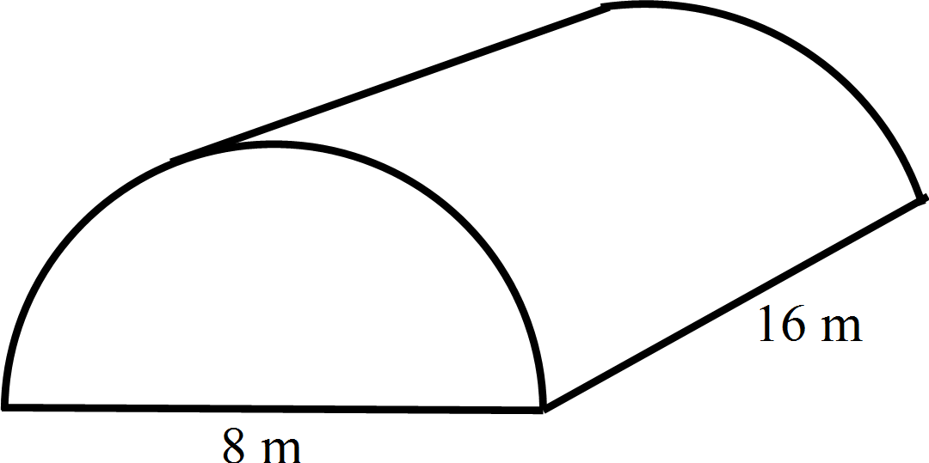A storage hut is in the shape of a half cylinder.
The diameter of the semicircle is 8 metres and the length of the hut is 16 metres.
What volume does the hut hold?

Volume = m³

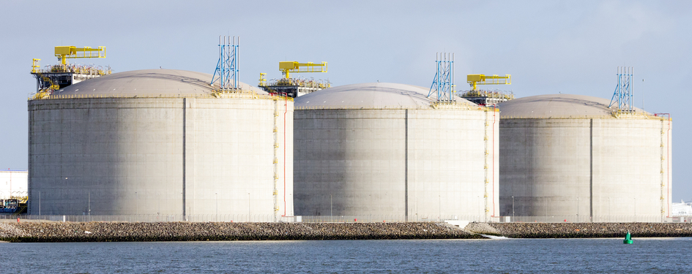
The petroleum storage tanks are cylinders which have a diameter of 80 metres and a height of 40 metres.

The top curved section is only used to contain vapour.

A cubic metre holds one kilolitre.

How many megalitres of petroleum would the three tanks hold?

Capacity of three tanks = Megalitres

Volume
ANSWERS
Non Calculator Section ( 1 mark each)
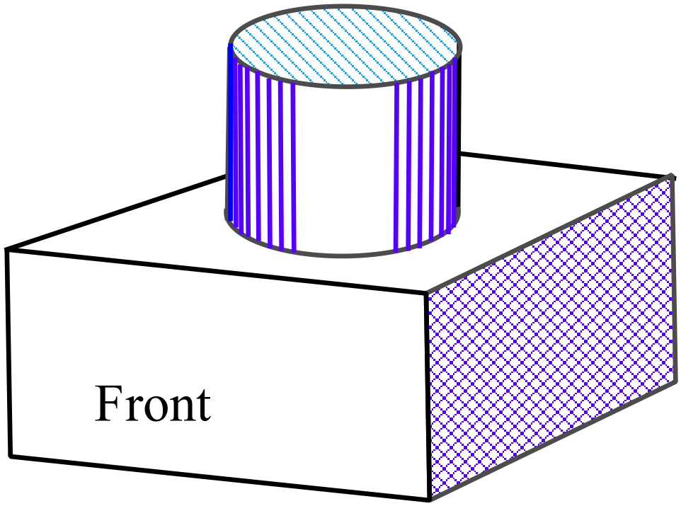For the solid shown, which diagram below correctly shows its front view (elevation) and top view (plan).

Draw a three dimensional sketch of the prism whose net is shown below.
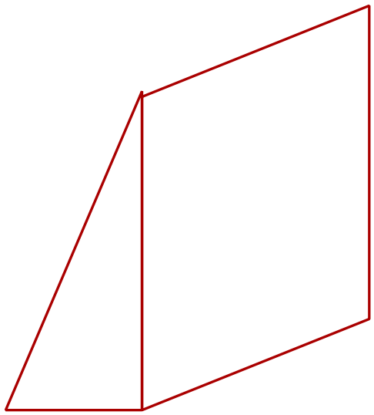

What name describes the solid shown?

Rectangular Prism.

Rectangular Pyramid.

Triangular Prism.

Triangular Pyramid.

What is the volume of the cube shown?

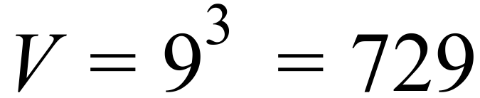

927
Volume = cm³

What is the volume of the rectangular prism?

216
Volume = cm³

Jimmy buys the glass aquarium shown and fills it to within 10 cm of the top.

How many litres of water are needed?

(1000 cm³ holds one litre.)

70 litres.

80 litres.

140 litres.

160 litres.

Josie buys a pizza in the box shown.

What is the volume of the box?

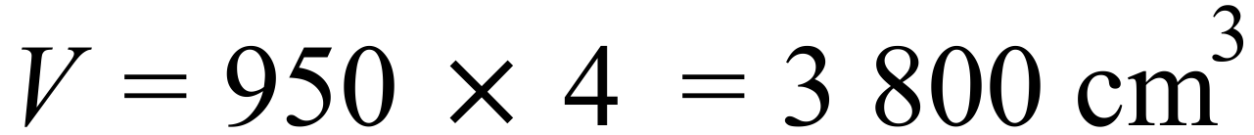

3 800
Volume = cm³

What is the volume of the prism whose net is shown here?

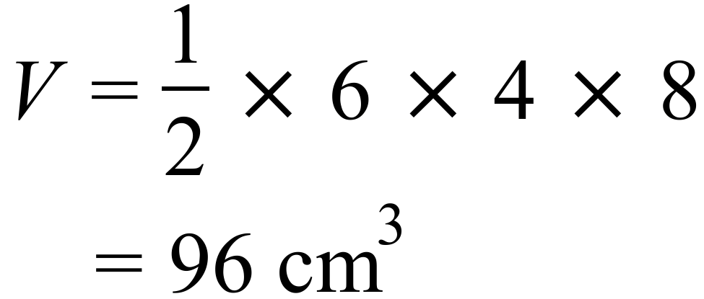

Volume = 96 cm³

What is the volume of the triangular prism shown?

900 cm³

4 500 cm³

9 000 cm³

18 000 cm³

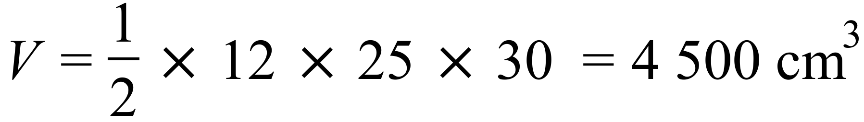
Each of these hexagonal boxes has a depth of 12 cm and the hexagonal top of each has an area of 90 cm².

What is the total volume of all the boxes shown?

3240
Volume = cm³
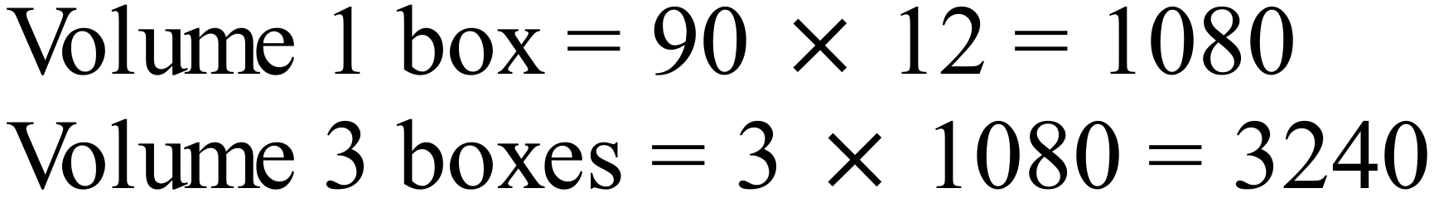

A dog kennel has the dimensions shown.
Calculate the volume of the kennel in cm³.
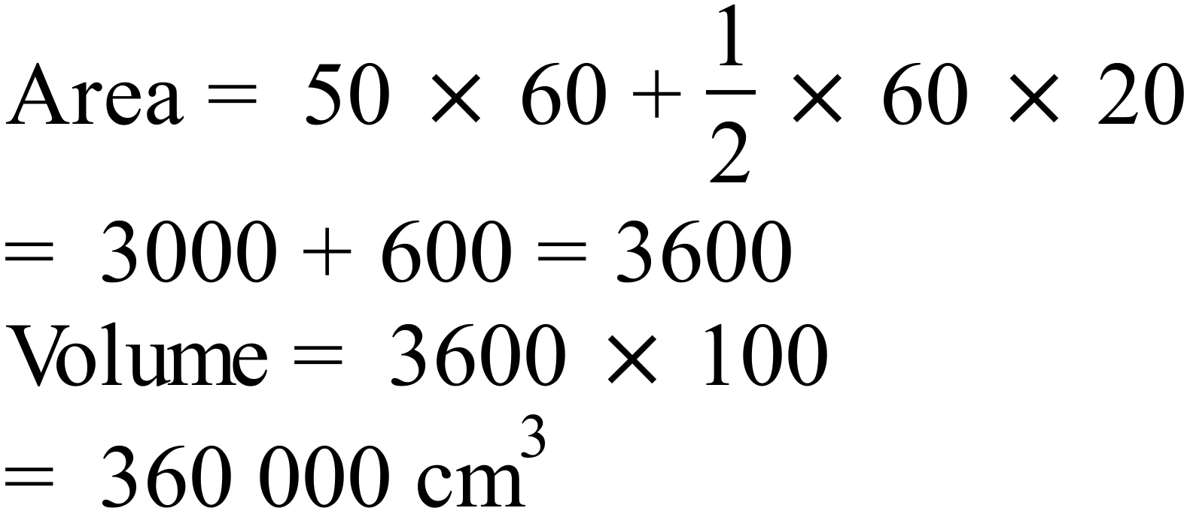

360 000
Volume = cm³.

A storage cabinet is in the shape shown.
What volume of storage does the cabinet provide?
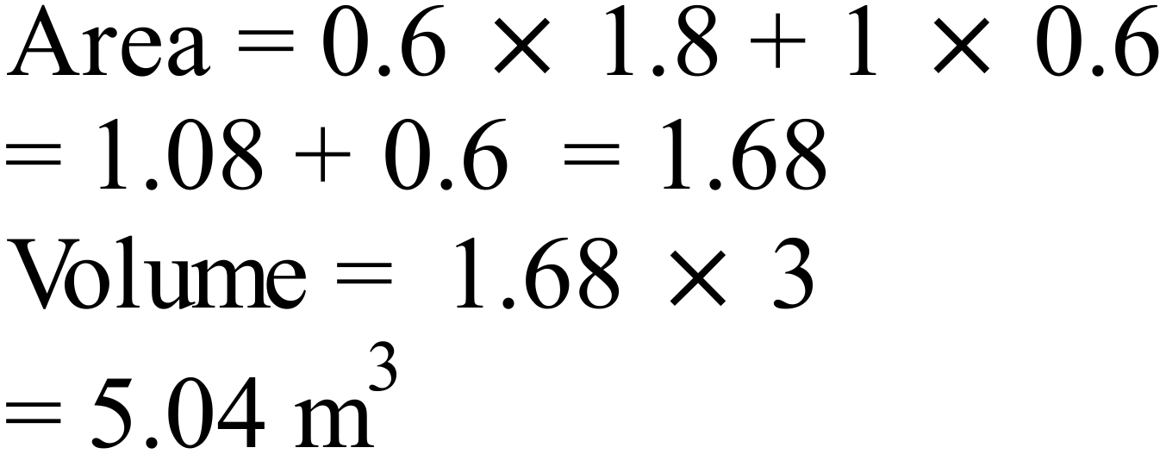

5.04
Volume of Storage = m³.

A gift box is in the shape of an octagonal prism that has 20 cm edges, measures 48 cm across and is 15 cm deep.

The octagon can be thought of as 8 isosceles triangles as shown.

Find the volume of the box.

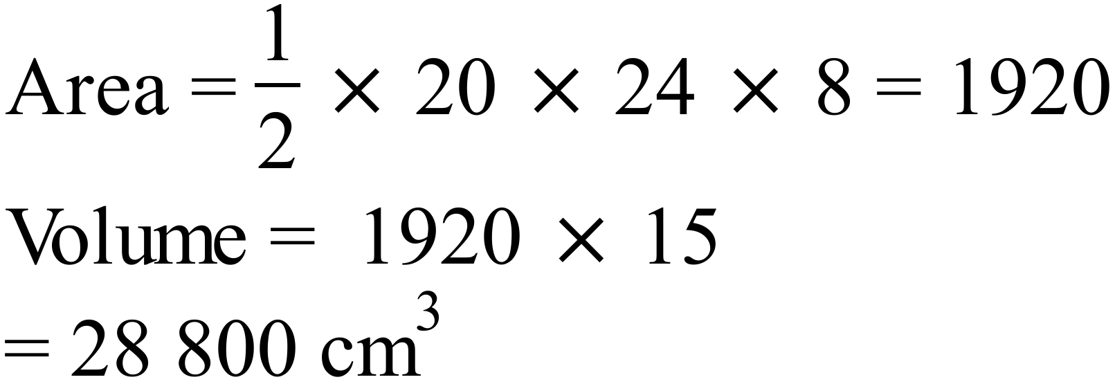

28 800
Volume = cm³

Find the volume of the cylinder in terms of
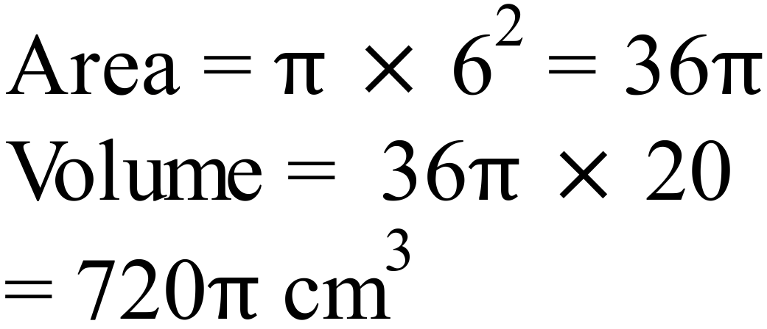

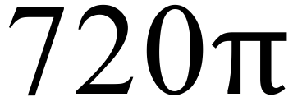
Volume = cm³

A letter box is a prism with its cross section shown below.

What is the volume of the lunch box?

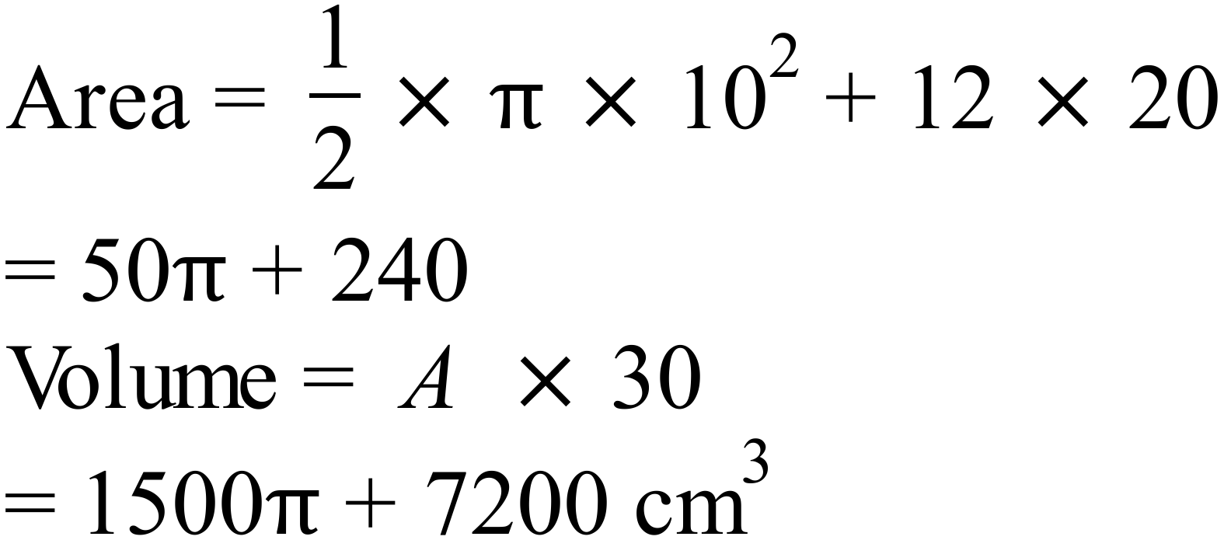

Calculator Allowed Short Answer Section ( 1 mark each)

Which solid below is not a prism?

Which of the solids shown would have the top and side view below?

The cube shown has a volume of 42.875 cm³.

What is the length of its edges?

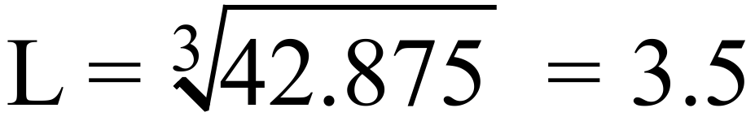

3.5
Length = cm.

What is the volume of the rectangular prism?
25.0 cm
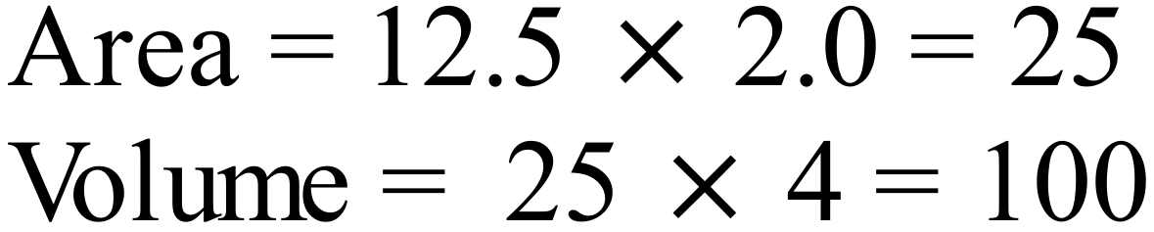

50.0 cm

100.0 cm

125.0 cm

What is the volume of the prism shown in cm³?

105 cm³
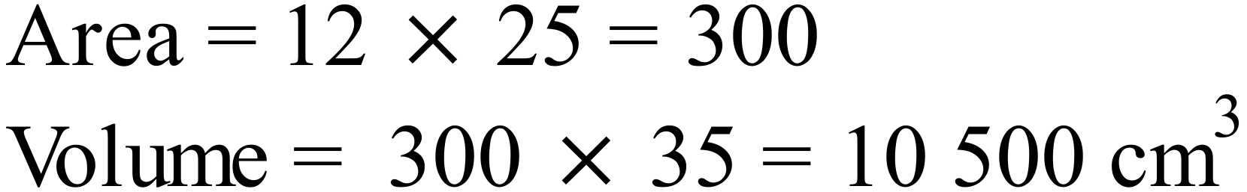
1 050 cm³
10 500 cm³
105 000 cm³

A prism has a volume of 6.5 m³. What is its volume in cm³?
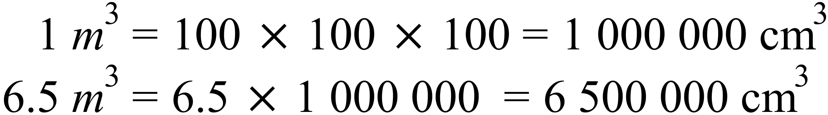

650 cm³ 65 000 cm³ 650 000 cm³ 6 500 000 cm³

Each of the cubes used in this design measure 2 cm on each side.
What is the total volume of the design?
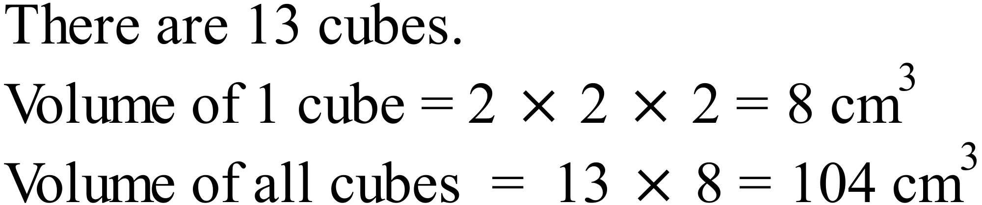
13 cm³

26 cm³

52 cm³

104 cm³

Which calculation could be used to find the volume of the triangular prism shown?

Find the volume of the triangular prism shown.
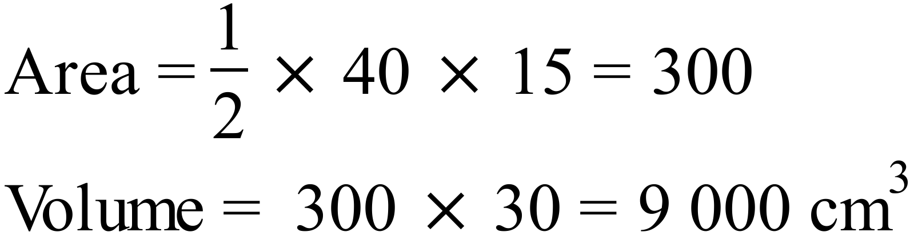

9 000
Volume = cm³

The area of the pentagonal base of this prism is 64.5 cm².

What is the volume of the prism?
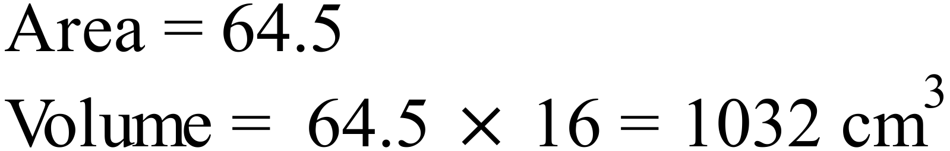

1 032
Volume = cm³

The water tank is designed to go under a deck and has the dimensions shown below.
Using the relationship: 1 cubic metre holds 1 kilolitre; find the capacity of the tank in litres.

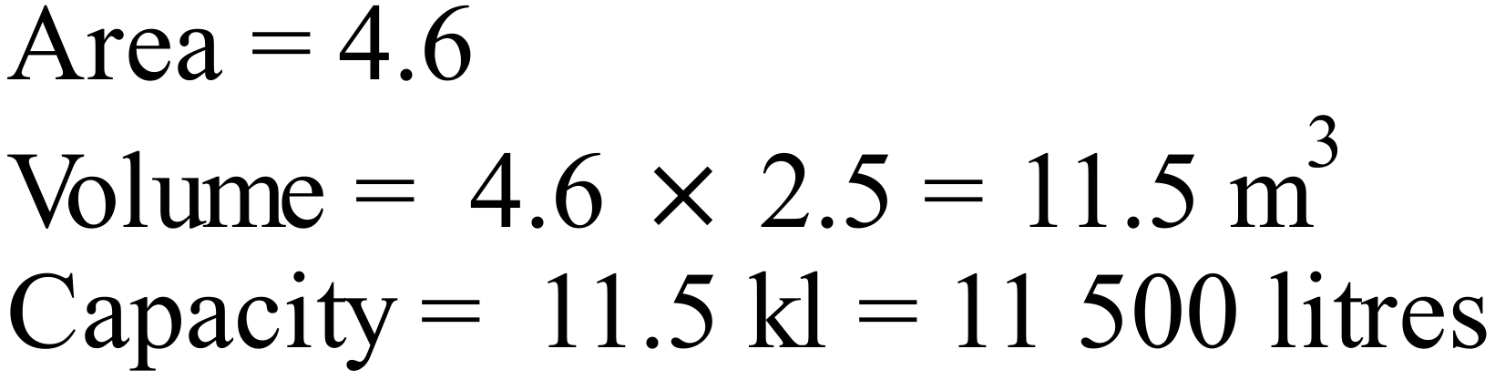

11 500
Capacity = litres.

Choc Delites are sold in a packet which is a triangular prism.

What is the volume of the packet shown?

35 cm³
37.5 cm³
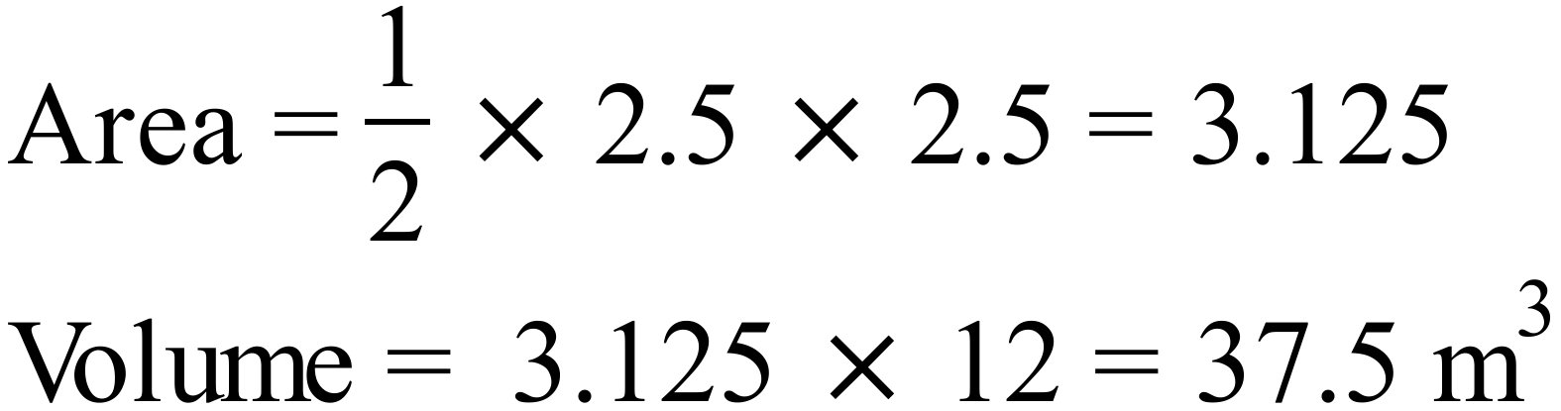
52.5 cm³
131.25 cm³

What is the volume of the cylinder to the nearest cm³?
2651
Volume = cm³.

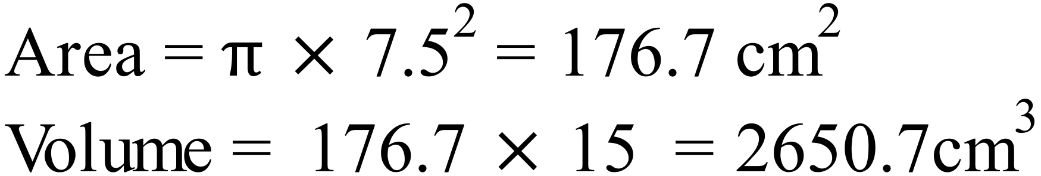

A storage hut is in the shape of a half cylinder.
The diameter of the semicircle is 8 metres and the length of the hut is 16 metres.
What volume does the hut hold?

402.1
Volume = m³
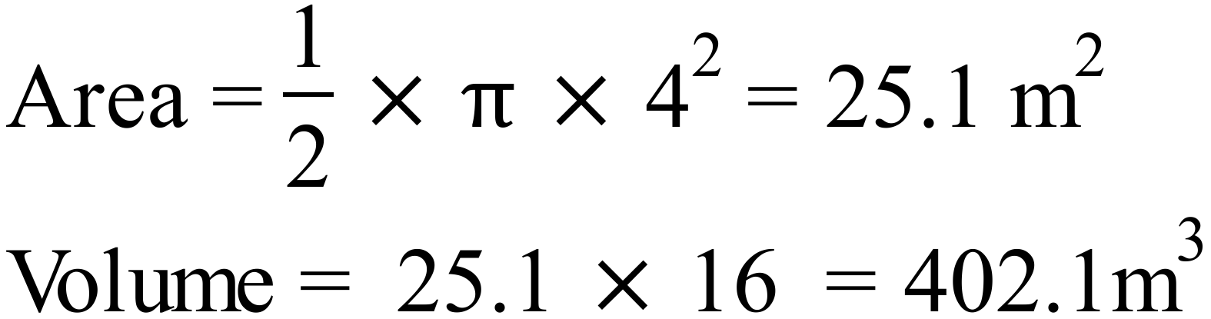

The petroleum storage tanks are cylinders which have a diameter of 80 metres and a height of 40 metres.

The top curved section is only used to contain vapour.

A cubic metre holds one kilolitre.
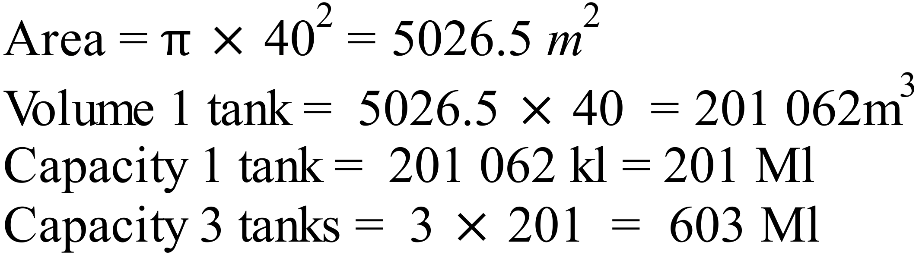

How many megalitres of petroleum would the three tanks hold?

201
Capacity of three tanks = Megalitres

